**DAILY ONLINE ACTIVITIES SUMMARY**

|  |  |  |  |  |  |  |  |  |
| --- | --- | --- | --- | --- | --- | --- | --- | --- |
| **Date:** | | **01st June 2020** | | | | | | |
| **Name of the Faculty** | | **VENKATESH** | | | | | | |
| **No. of Students Allotted for monitoring** | | | | | **27** | | | |
| **Progress** | | | | | **Good** | | | |
| **Whether collected report from all the allotted students** | | | | | **27** | | | |
| **Online Test Summary** | | | | | | | | |
| **Subject** |  | | | | | | | |
| **Semester** |  | | | **Duration** | |  | | |
| **No. of students Taken** | | |  | **Passing %** | |  | | |
| **Certification Course Summary** | | | | | | | | |
| **Course** | | 1. **Introduction to R** 2. **Webinar on “Personality Development Through Online Courses - The 3-Dimensional Learning”** 3. **Webinar on “MASTERING MACHINE LEARNING – AN INTRODUCTORY GUIDE”** 4. **Webinar on "UNDERSTANDING SOCIAL MEDIA THROUGH ANALYTICS”** 5. **Webinar on “RESEARCH INNOVATION AND SKILL DEVELOPMENT”** 6. **Webinar on “Understanding Analytics”** | | | | | | |
| **Certificate Provider** | | 1. **ALISON** 2. **Vivekanada Institute of Technology, Bangalore** 3. **PANTECH** 4. **PANTECH** 5. **BIT Bellary** 6. **SRIT, Bangalore** | | | | | **Duration** | 1. **3 Hours** 2. **2 Hours** 3. **1 Hour** 4. **1 Hour** 5. **2 Hour** 6. **2 Hour** |
| **Coding Challenges** | | | | | | | | |
| **Problem Statement: Given an array of positive integers. Write a C Program to find the leaders in the array.** | | | | | | | | |
| **Status: Total 35 Students were solved.** | | | | | | | | |
| **Uploaded the report in Github** | | | | | **Yes** | | | |
| **If yes Repository name** | | | | | [https://github.com/Venkateshbhat2007/](https://github.com/Venkateshbhat2007/Online-Daily-Activities) | | | |
| **Uploaded the report in slack** | | | | | **Yes** | | | |

# [Introduction to R](https://alison.com/course/introduction-to-r)

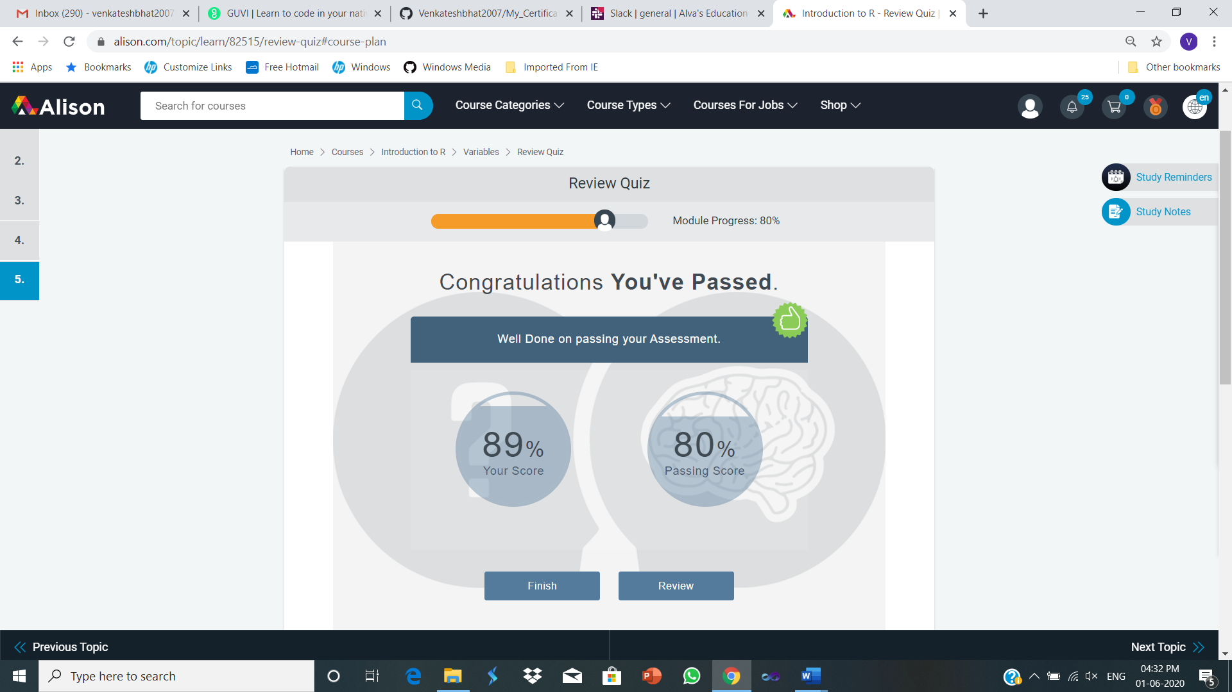

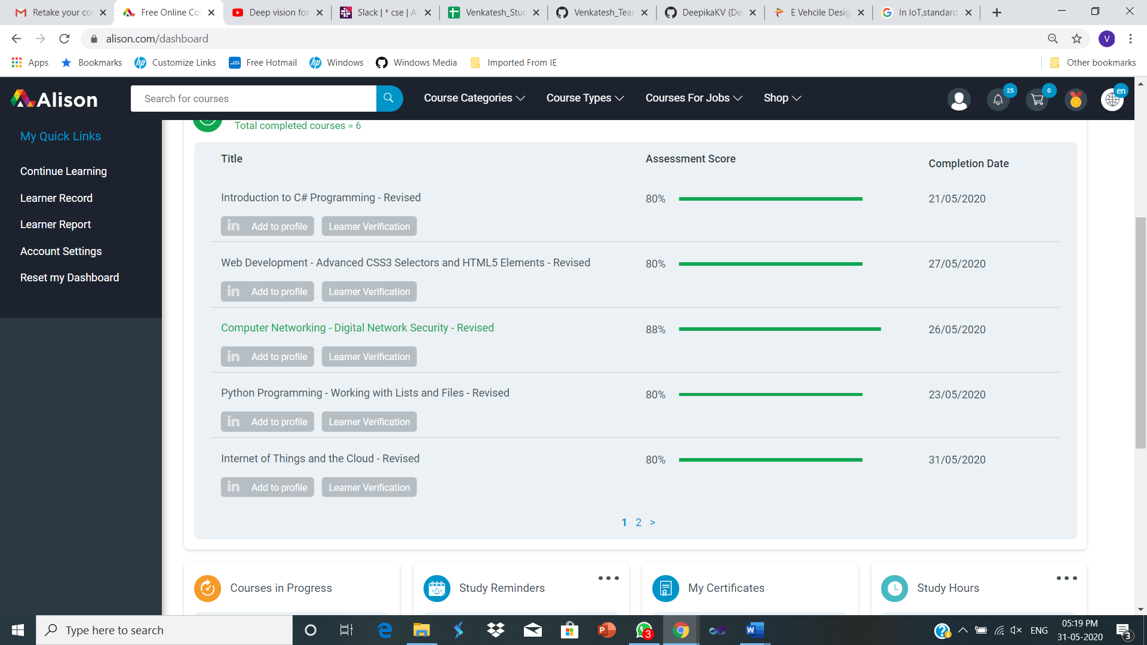

**Webinar on “Personality Development Through Online Courses - The 3-Dimensional Learning”**

**By**

**Vivekanada Institute of Technology, Bangalore**

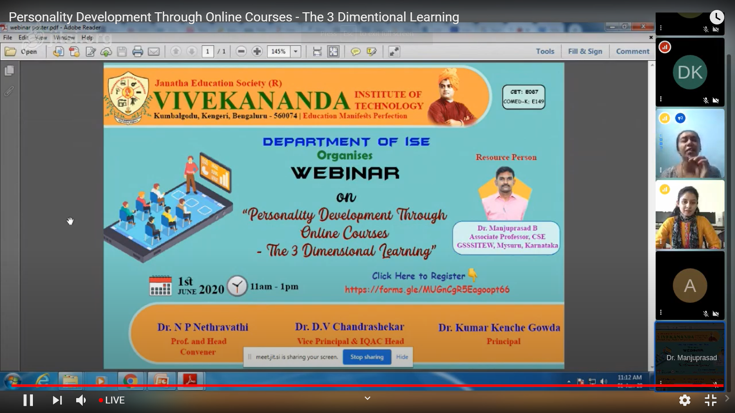

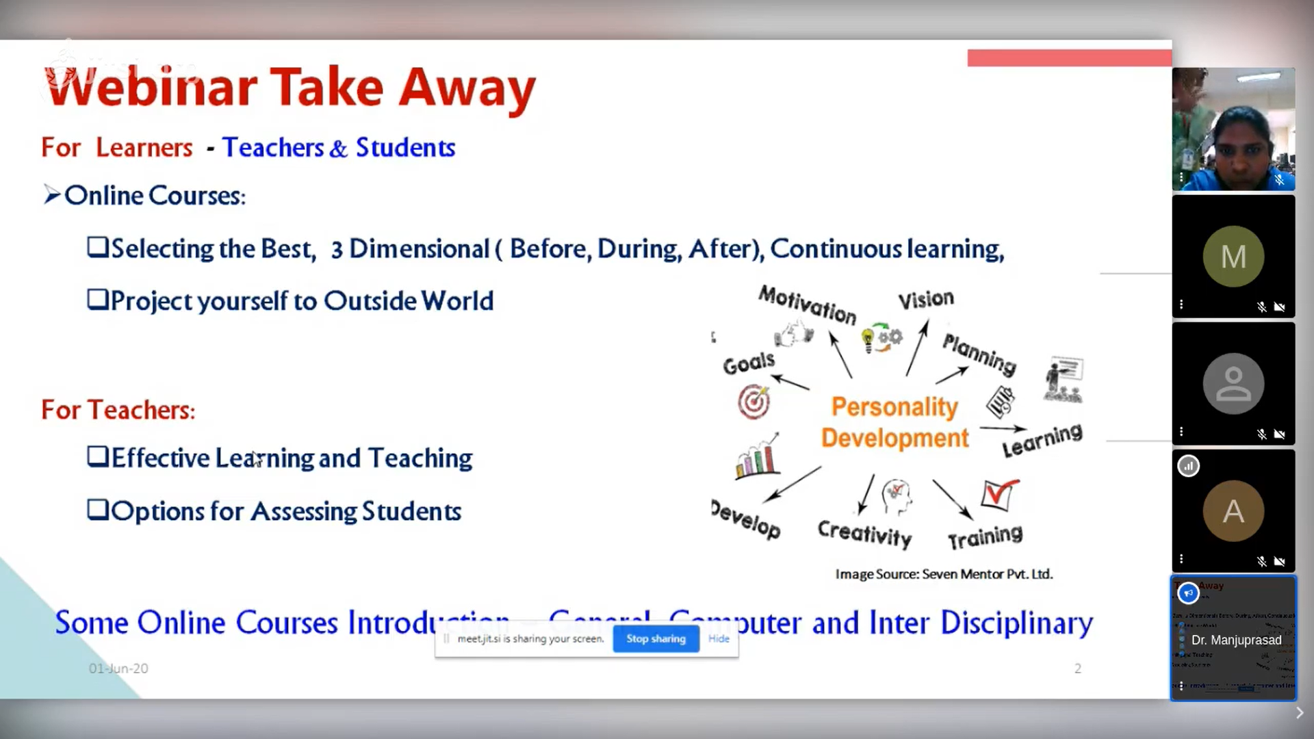

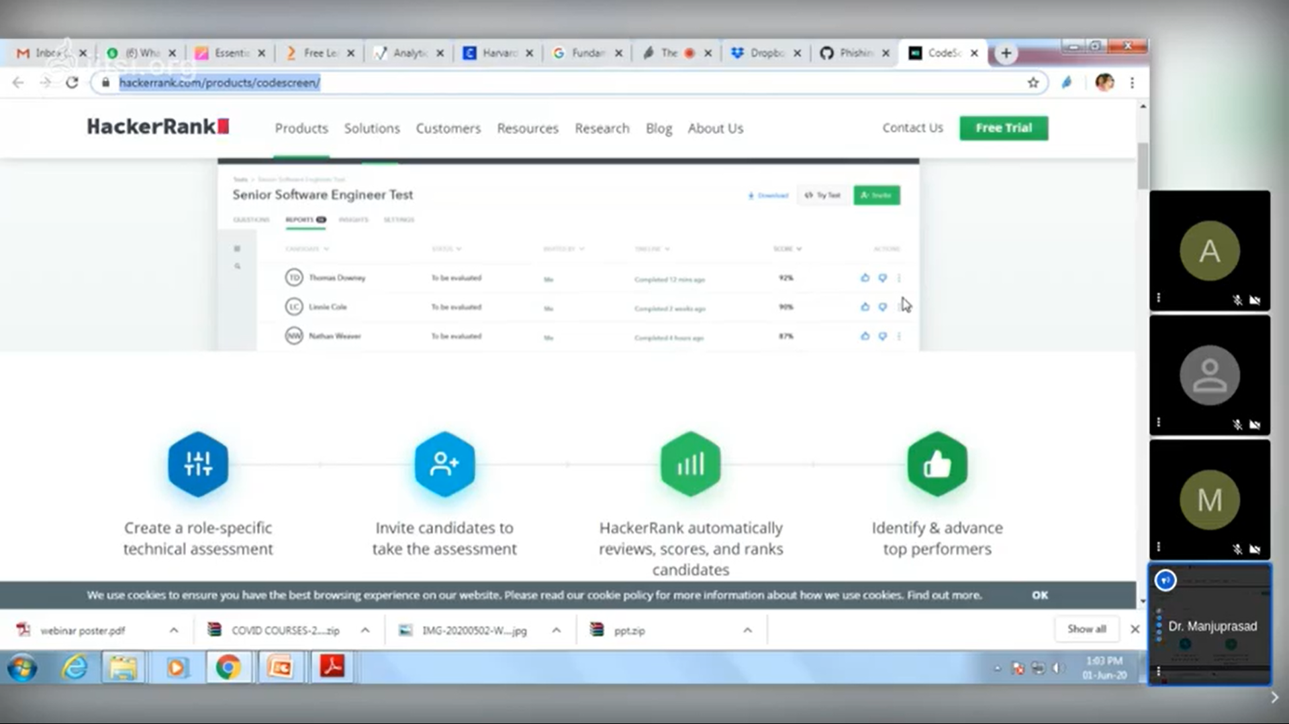

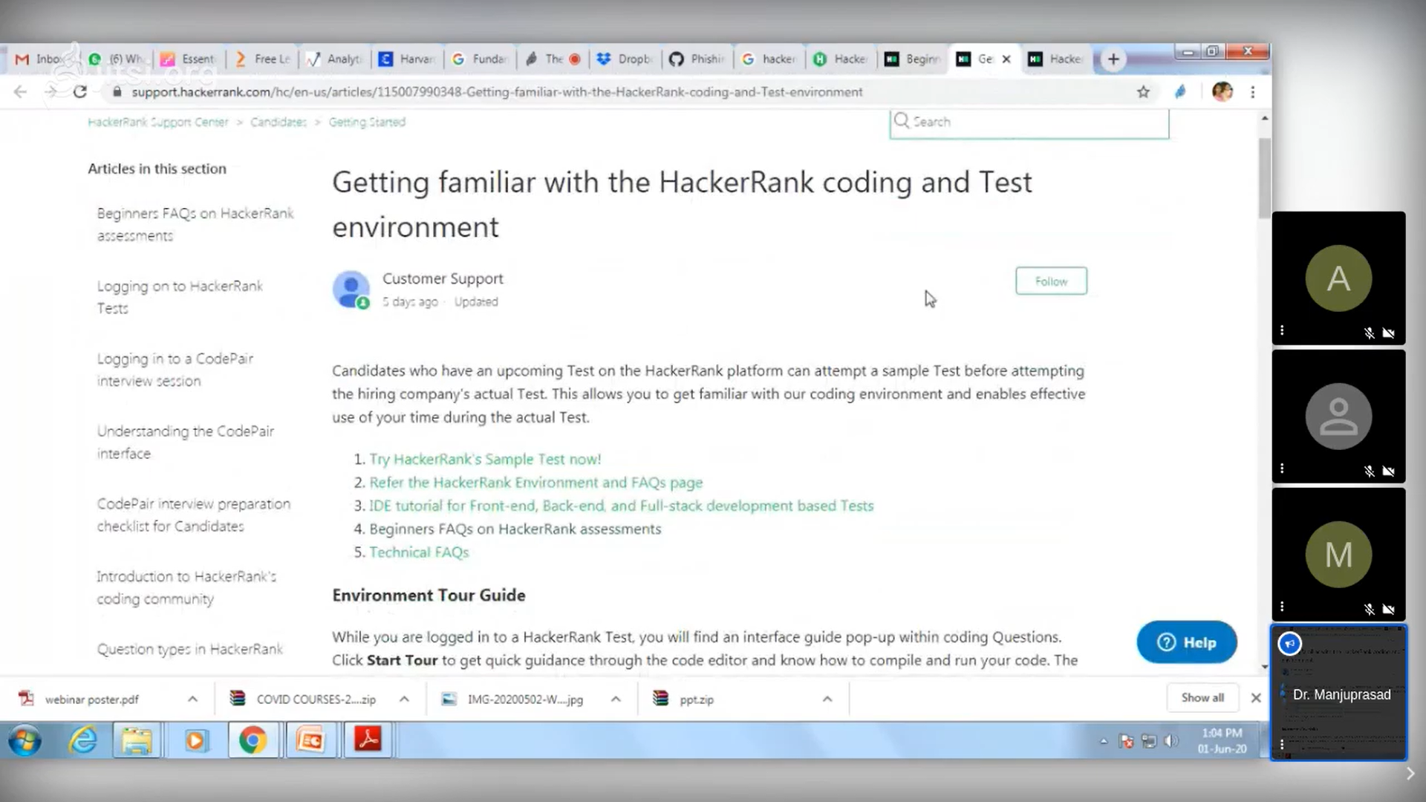

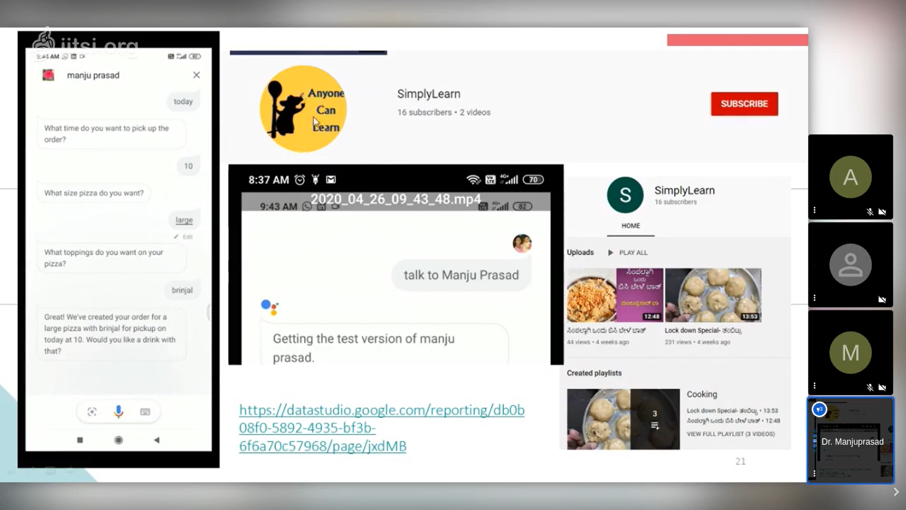

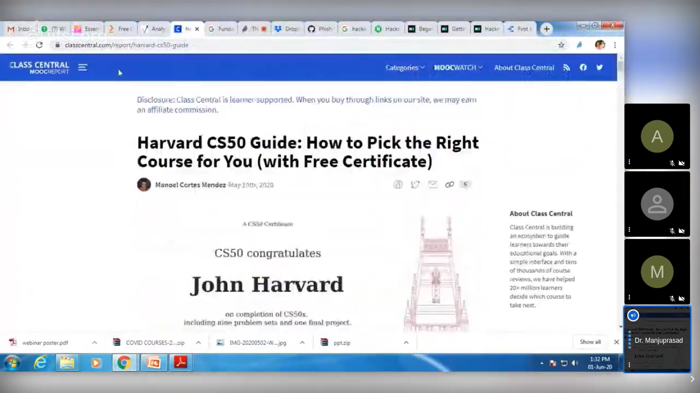

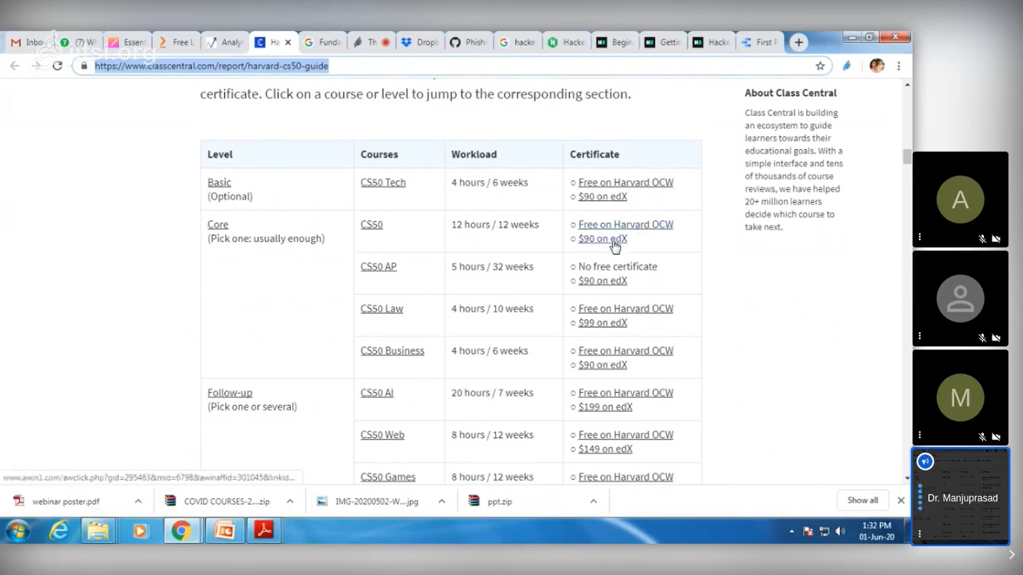

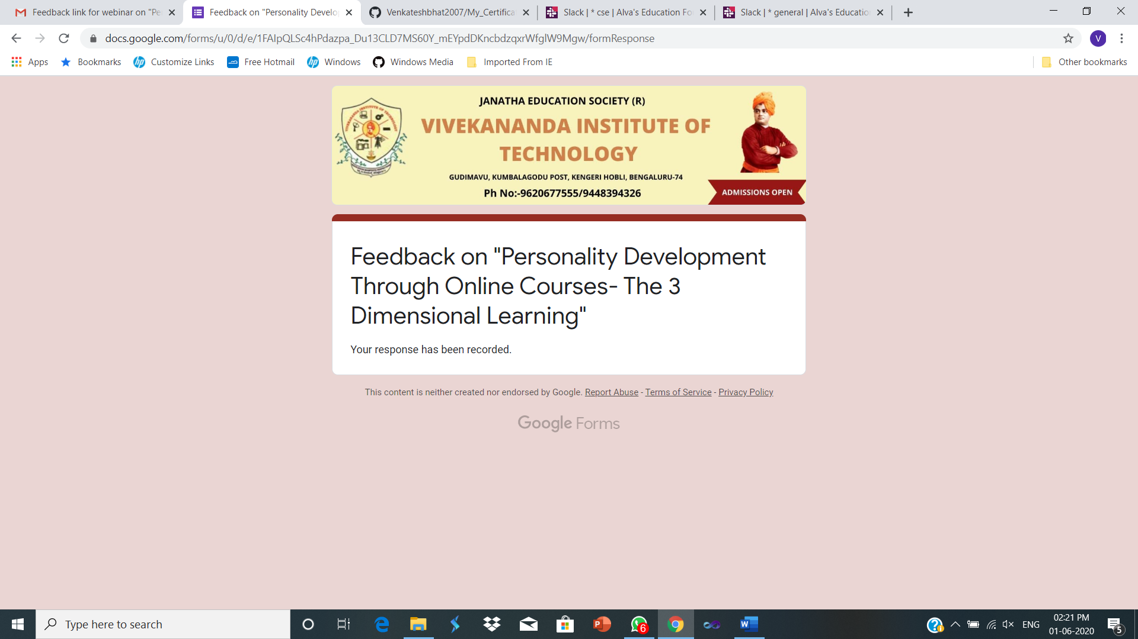

**Webinar on “MASTERING MACHINE LEARNING – AN INTRODUCTORY GUIDE”**

**By PANTECH**

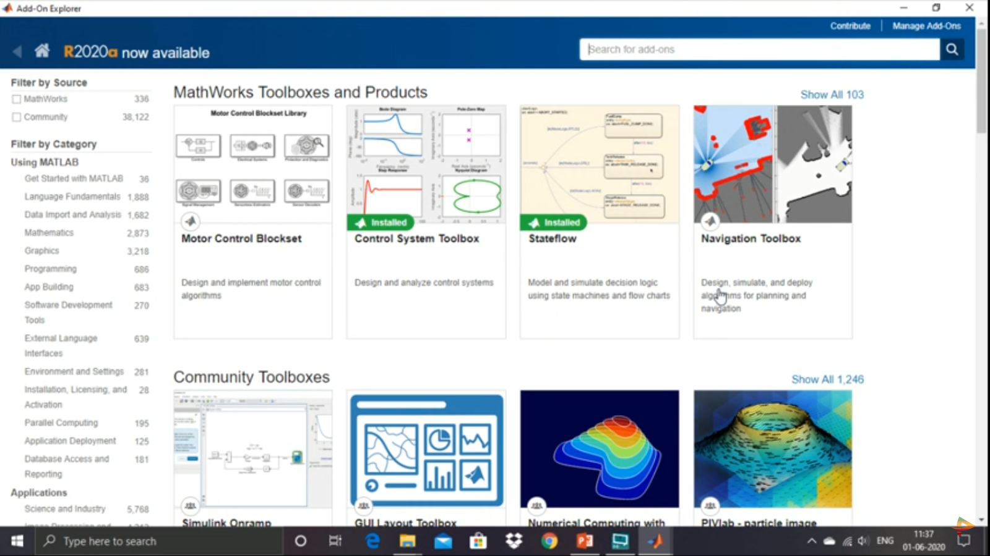

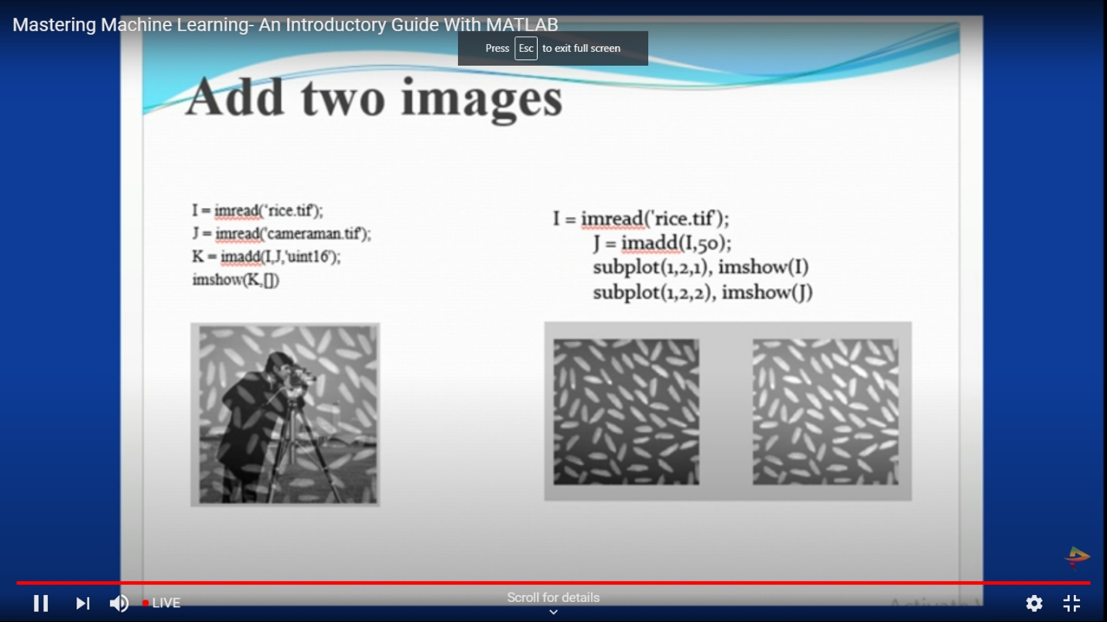

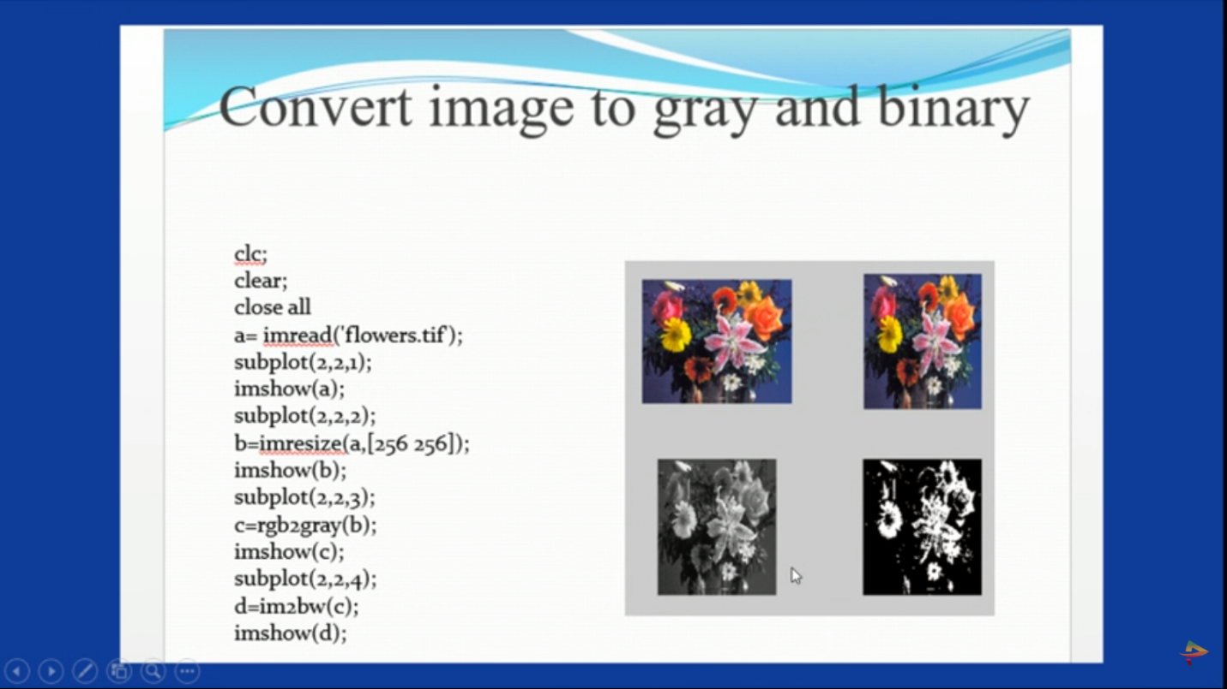

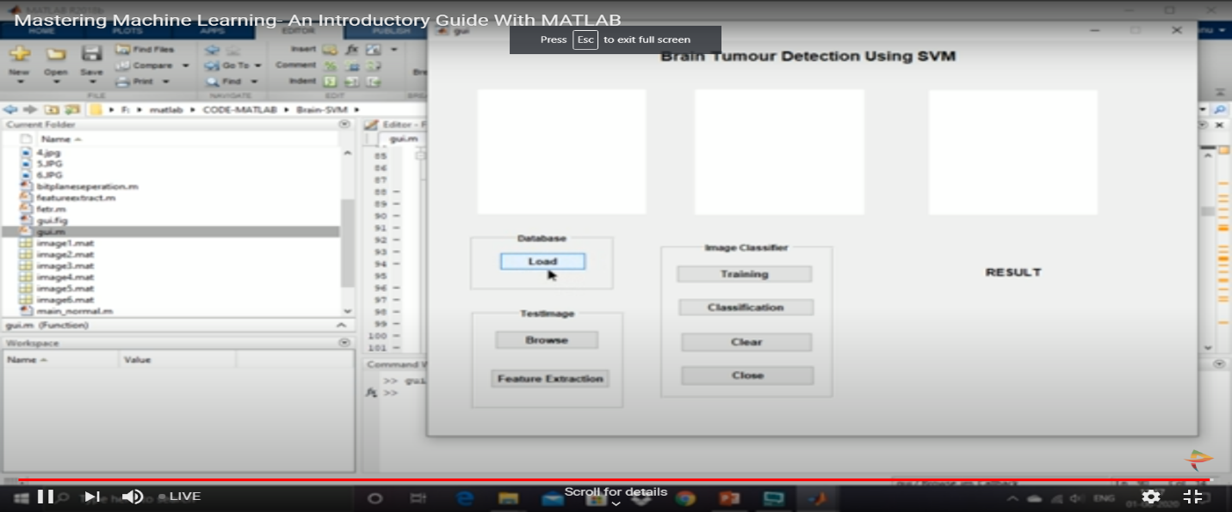

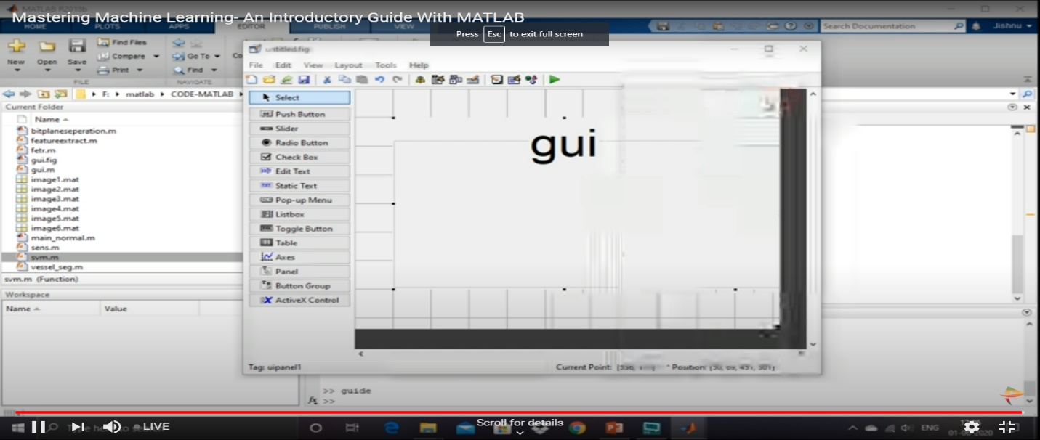

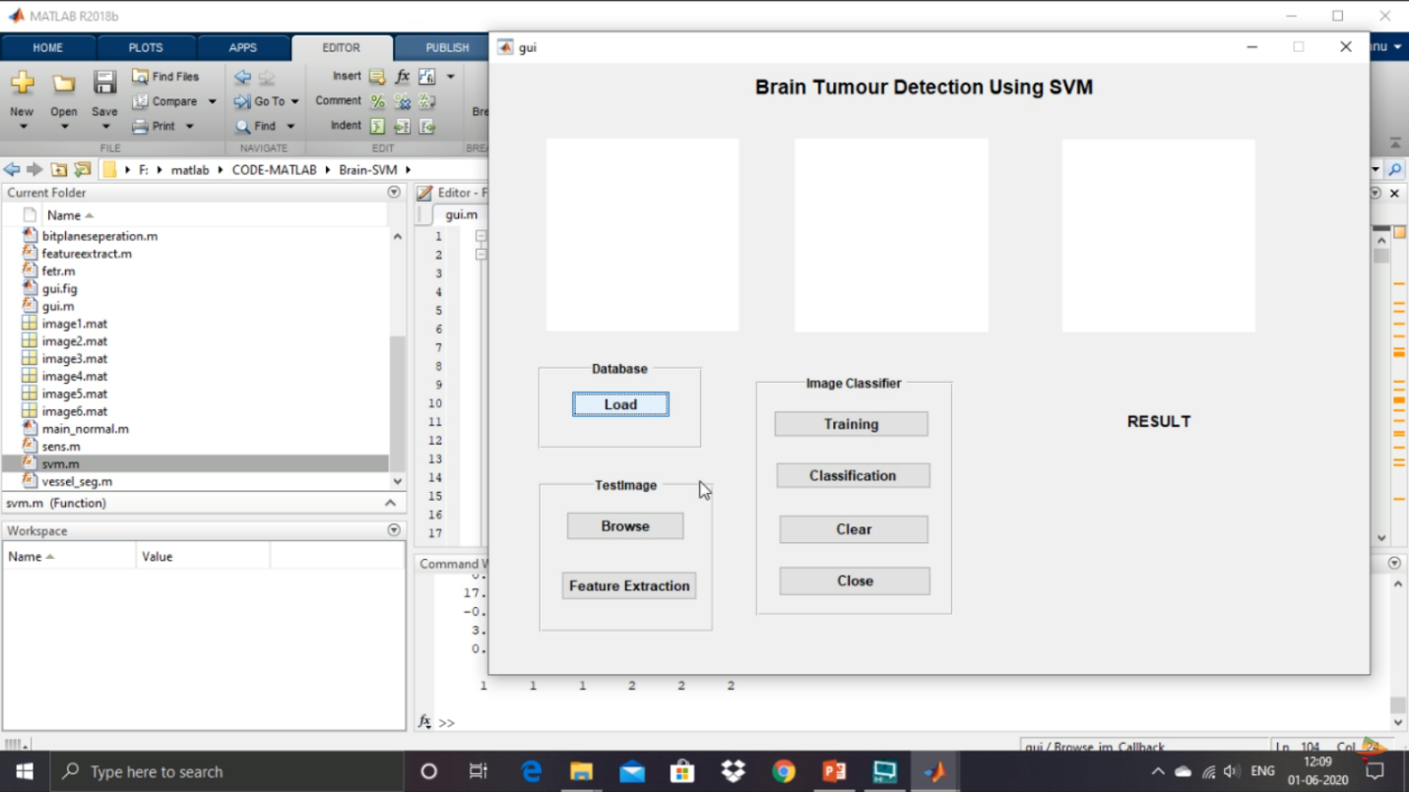

**Webinar on "UNDERSTANDING SOCIAL MEDIA THROUGH ANALYTICS”**

**By PANTECH**

**Webinar on RESEARCH INNOVATION AND SKILL DEVELOPMENT**

**By BIT Bellary**

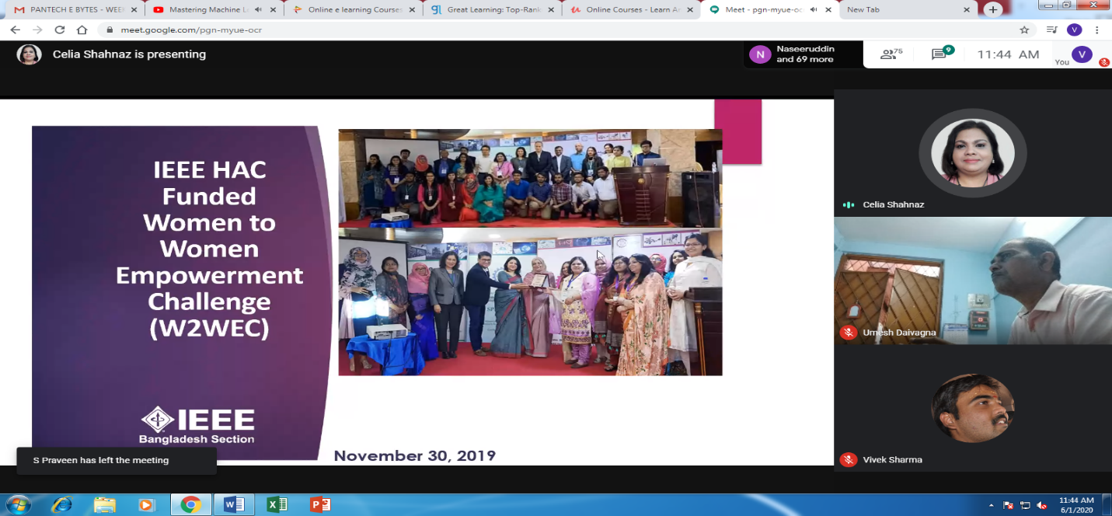

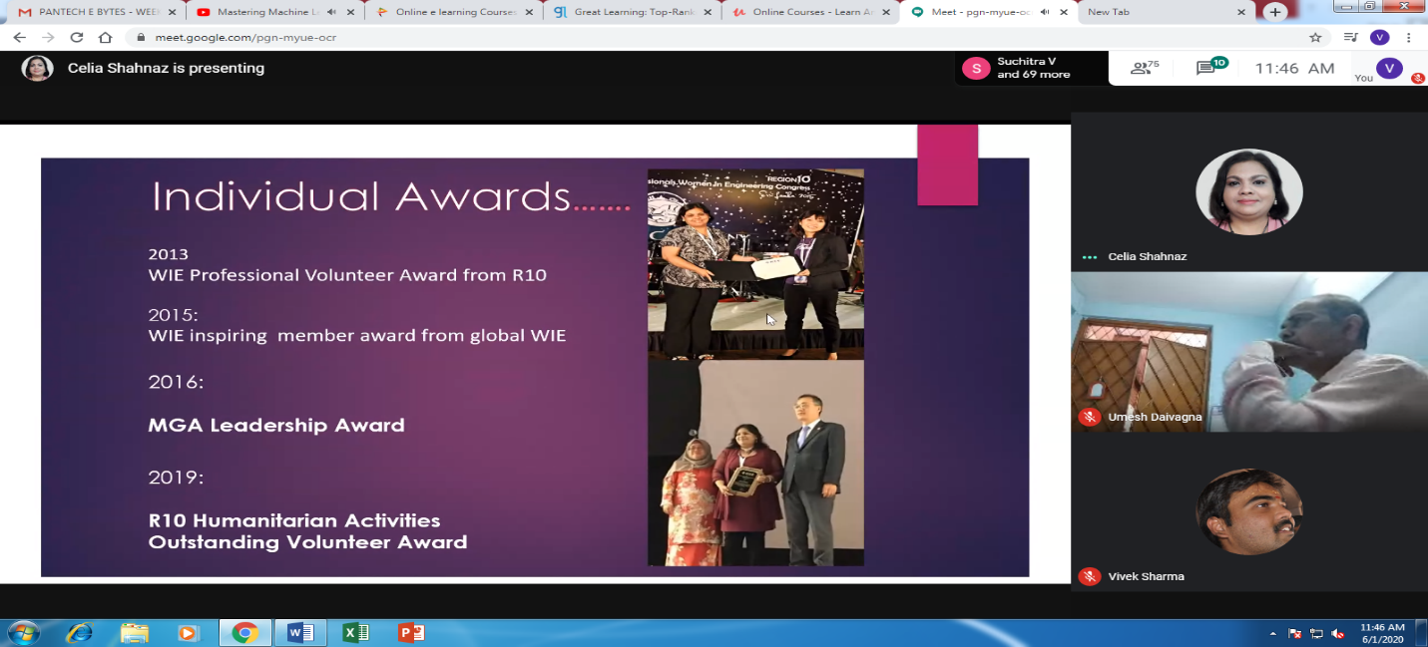

**Understanding Analytics**

**By SRIT, Bangalore**

